**Level 6 Mini signs 2019**

63 A. 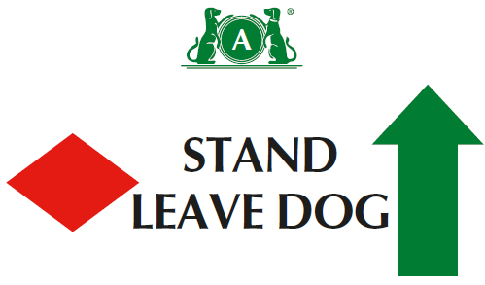

63 B. 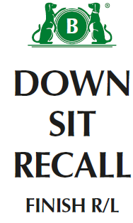

64 A. 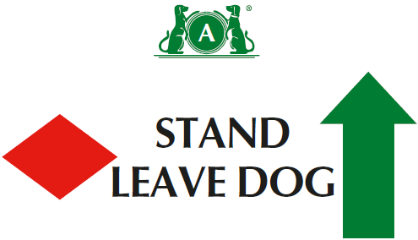

64 B. 

65 A. 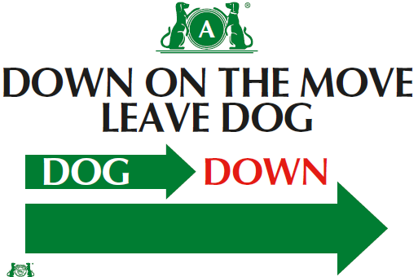

65 B. 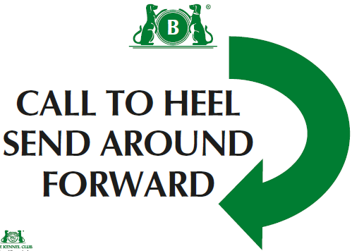

66 A. 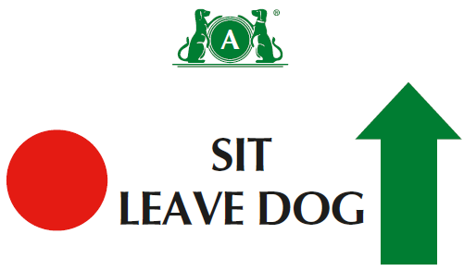

**Level 6**

(1) There should be a minimum of sixteen and a maximum of eighteen exercises, with no more than sixteen static positions.

(2) There should be a minimum of one and maximum of four exercises from Level 5, and a minimum of one and a maximum of four exercises from Level 6.

(3)No more than 2 jump exercises in a course.

(4)Can join 2 cone exercises using junction( ie across centre or at end at right angles)- advise use 1 different coloured cone if joining spiral to serpentine or fig 8

(5) Bonus can come from bonus exercises 1-15

66 B. 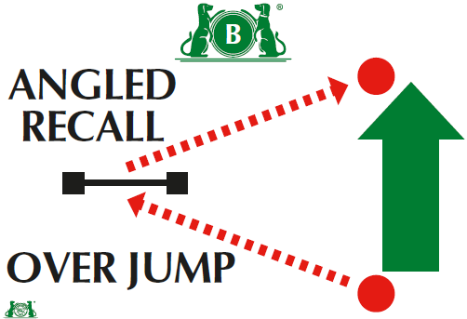

67. 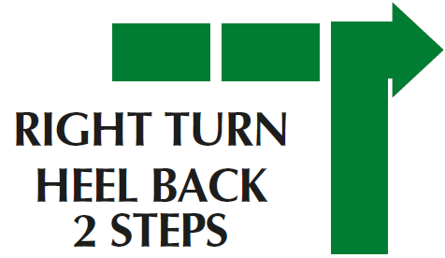

68. 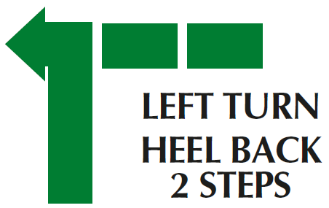

Bonus Ex 13.

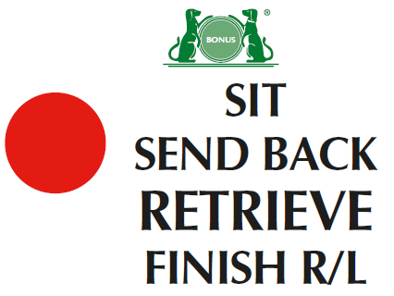

Bonus Ex 14

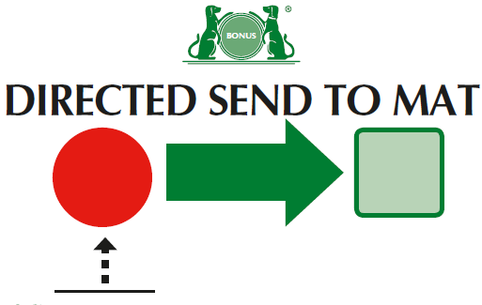

Bonus Ex 15

